**SHORT-TERM CONTRACT FOR MODELLING APPROACHES: SUPPORT TO BFT**

**ASSESSMENT (GBYP 06/2016) OF THE ATLANTIC-WIDE RESEARCH PROGRAMME ON**

**BLUEFIN TUNA (ICCAT-GBYP – Phase 6)**

Tom Carruthers, Blue Matter Science Ltd (bluemattersci@gmail.com)

12th July 2016

**Progress Report 4**

# Current status of deliverables and actions required to achieve them

|  |  |  |
| --- | --- | --- |
| **Deliverable 1 July 20, 2016 (100%)** | | |
|  | i | Workplan outlining the actions required to complete the 5 components of deliverable 3 |
|  | ii | Presentation and short report summarizing current status of deliverables and actions required to achieve them |
|  |  |  |

The purpose of this document and an accompanying presentation is to address deliverable ii. The workplan(deliverable i) is described in Section 4 below.

|  |  |  |
| --- | --- | --- |
| **Deliverable 2 September 23, 2016 (0%)** | | |
|  | i | Updated presentations and short report summarizing current status of deliverables and actions required to achieve them |
|  | ii | Demonstrator showing the MSE running, should include examples of the 6 steps of developing an MSE |
|  | iii | Draft papers on applications |
|  |  |  |

(ii and iii) These deliverables are contingent on the latest version of the operating model (M3 v1.18) fitted to data (bluefin data preparatory meeting 2016 is a precursor) and finalization of the trial specifications (TS) document.

The R demonstration / tutorial first requires establishing appropriate steps of MSE development. For example Punt and Donovan (2006) describe an MSE conceptual framework with 7 parts. A demonstration MSE will be set up in R for advanced users that addresses the core components of such a framework:

(1) qualitative specification and prioritization of the management objectives, as derived from legislation, legal decisions, and international standards and agreements;

(2) quantification of the qualitative management objectives in the form of performance measures;

(3) development and parameterization of a set of “operating models” that represent different plausible alternatives to the dynamics of the “true” resource and fishery being managed;

(4) identification of candidate management procedures, including monitoring strategies;

(5) simulation of the future use of each candidate management procedure, involving for each time-step during the projection period: (a) generation of assessment data; (b) determination of the management action (i.e. assessment and application of some HCR); and (c) evaluation of the biological implications of the management action by removing the catch from the population as represented in the operating model;

(6) summary of the performance of the candidate management procedures in terms of values for the performance measures; and

(7) selection of the management procedure that best meets the specified objectives.

A summary demonstration of MSE results will be set up in a shiny app (e.g. [**http://rscloud.iccat.int:3838/gbyp-mse/**](http://rscloud.iccat.int:3838/gbyp-mse/)**)** following feedback from the bluefin WG, CMG and stakeholders on the design of this graphical tool.

|  |  |  |
| --- | --- | --- |
| **Deliverable 3 Draft: February 13, 2017 Final: February 21, 2017** | | |
|  | i | Repository with version control for software development <http://github.com/ICCAT/abt-mse> containing the OM |
|  | ii | SDP (Software Development Plan) that will be reviewed by external experts, as agreed at Monterey meeting (~50%) |
|  | iii | Test Unit so that code can be validated (~80%) |
|  | iv | Meta Database summarizing all parameters and assumptions used <http://github.com/ICCAT/GBYP-MetaDB> |
|  | v | Management Procedures Support the implementation of 3rd parties. Written up as SCRS paper and code available in repository |
|  |  |  |

(i) Currently an ICCAT MSE GitHub site provides a system for distributed version control. Before the next update, the M3 and ABT-MSE R framework should be formalized in projects and the online repository linked to local repositories. Management of branching, merging, pulls, commits etc. can either fall on the Technical Assistant or ICCAT staff.

The most recent update was an updated M3 operating model (v0.17) in February 2016. This version is subject to update to follow the recommendations of the core modelling group (CMG). This latest version (v.0.18) is currently subject to simulation testing. After it has been demonstrated that it does not produce spurious estimates of stock status, trajectory and core reference points it can be pushed to the repository.

(ii) A software development plan is currently being developed Software design documents and manuals are available for the M3 operating model. Following feedback from the bluefin working group (BFT WG), core modelling group (CMG) and SCRS the ABT-MSE R framework can be finalized and a manual and software design document can be

(iii) A test unit has been developed that matches the new features of the latest M3 model (v0.18). The simulator is built into the R ABT-MSE framework and uses streamlined operating model objects (OM definition objects) to generate simulations and calculate reference points. The test unit (and M3 model) must both be updated to reflect recommendations of the CMG, BFT WG and SCRS following the 2016 data preparatory meeting.

# Current status of objectives

|  |  |  |
| --- | --- | --- |
| **Objective** | | **Tasks (bold are completed)** |
| **a**  (contingent on finalization of TS) | Continue the development of the OM based on the MSE trial specifications document (TS) | **Added (M3 v0.18):**  **age-based movement, plus group, model initialization at equilibrium estimated F, recruitment predicted from SSB in previous year, a prior for depletion to allow the model to fit specified depletion.** |
| **b**  (100%) | Develop a test unit to validate the age-based movement model | **Test unit updated to match developments in the operating model above (a)** |
| **c**  (0%) | Work with third parties to add MPs to the MSE framework including empirical control rules and simple stock assessment methods | Reach out to national scientists, members of the BFT WG (possibly leverage the chairs of Eastern and Western WGs) and the CMG to develop new MPs or to incorporate existing MPs (e.g. CCSBT) |
| **d**  (0%) | Run the MSE in collaboration with BFT Species group | Requires a dedicated meeting following finalization of the TS, fitting of the appropriate OMs and integration of these into the R ABT-MSE framework. |
| **e**  (50%) | Collaborate with the SCRS to develop interactive graphics (e.g. Shiny apps) to communicate MSE results to stakeholders based on the performance metrics of the trial specifications document | **A preliminary Shiny App is now available at:** [**http://rscloud.iccat.int:3838/gbyp-mse/**](http://rscloud.iccat.int:3838/gbyp-mse/)  The App should be modified following feedback from the BFT WG and stakeholders.  The App should include sufficient flexibility to allow users to define their own OMs. |
| **f**  (depends on data prep meeting) | Work with other to update and maintain the meta database of the available bluefin data and knowledge https://github.com/ICCAT/GBYP-MetaDB | During and after the 2016 data preparatory meeting, discuss data availability and collaboration with those data providers listed in the MetaDB |
| **g**  (0%) | Work with SCRS to help develop 3 prototype examples | Follows finalization of the TS, fitting of the appropriate OMs and integration of these into the R ABT-MSE framework. |

# Addressing critical issues for MSE adoption

## Stakeholder specification of OMs

There are two levels at which stakeholders may specify OMs. The first is at the ground level in the description of the trial specifications document (TS). This determines the range of scenarios that the OM (M3) will be fitted to data.

The second level is post-hoc and may be achieve through various combinations of the OM conditions identified in the TS. For example a stakeholder may select a unique combination of mortality rate, stock depletion, stock-recruitment relationship, bias in reported catches and test MP robustness to this particular reference case. The second level of stakeholder specification may be achieved through graphical MSE summary tools such as a shiny app. An online interactive table may be updated to allow for various OM types to be added by stakeholders.

## User specified MPs

The ABT-MSE R framework is designed specifically to allow user defined MPs to be easily incorporated. The central obstacles for successfully engaging with stakeholders on MP development are materials (tutorials, examples, demos) that clearly explain this functionality. It may be necessary to organize a dedicated MSE workshop once a working MSE framework is established.

## Custom performance metrics

The process of establishing management objectives (e.g. biomass above BMSY) and target performance metrics (probability of being above 50% BMSY after 10 years) relies on engagement with stakeholders. Typically this is an iterative approach and stakeholder require working MSE results to begin an informed decision about types of performance (short term yield, long term yield, stability in yield, biomass levels) targets and limits for these and probabilities of exceeding these. Interactive tools such a shiny apps and Bayesian belief networks offer a possible means of making MSE outputs accessible to stakeholders with a wide range of backgrounds and abilities.

# Workplan for achieving deliverable 3

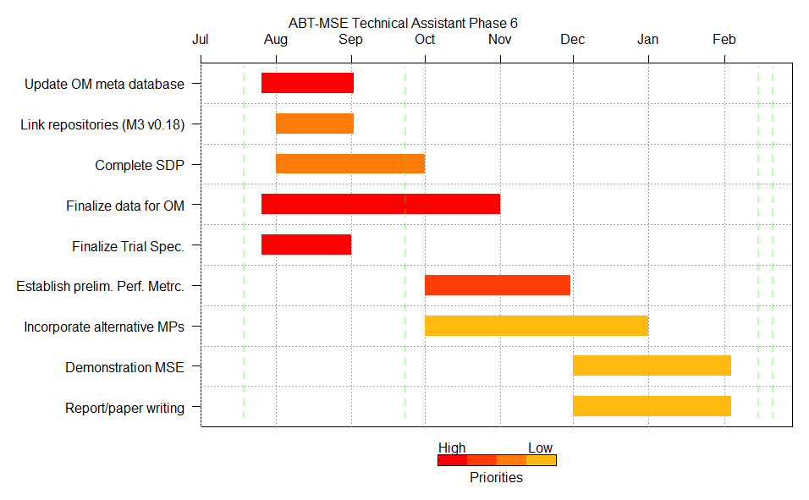

**Figure 1**. Gantt chart of possible workflow for MSE technical assistant 2016-2017. Tasks are color coded to represent current priority level. Vertical green lines are deliverable dates.

## Repository with version control (August 2016)

I intend to use the distributed version control system of GitHub to link local and ICCAT server repositories for the M3 operating model and the ABT-MSE R framework. The repository and credentials should be shared among prospective developers of MPs etc. The repository may be managed either by myself or the secretariat (management of credentials, branching, commits, pushes and pulls).

For each simulation tested version of the OM and any revision of the ABT-MSE R framework, new versions will be committed.

## Software development plan (October 2016)

A current software design document is being drafted for ABT-MSE R framework. A draft manual and software design document for M3 OM version 0.17 has been submitted previously (these need to be updated to version 0.18). An overview of the software design and the interaction of the OM and MSE frameworks is illustrated in Figure 2.

This overview highlights the core bottlenecks for making progress (highlighted in red). Recognising that MSE development is iterative and that progress if often made in light of working examples, the order of processes in Figure 2 dictates their priority. For example, until the fishery data, electronic tag and biological data are available, the M3 model cannot be fitted to data and it may not be clear to stakeholders what management objectives and performance metrics are realistic (e.g. BMSY stock levels within 10 years may not be possible if OM fits indicate that stocks are heavily depleted). Similarly, until a working operating model has been established and performance metrics identified, it is difficult for users to design management procedures since it may not be clear what MPs should aim to achieve (for example an MP that achieves BMSY on average is undesirable if managers are targeting a biomass above BMSY).

It follows that the current software design plan aims to address components of Figure 2 that need to happen first and are the highest ‘upstream’ of the final prospective MP selection.



**Figure 2.** MSE software design and workflow, status and priorities.

## Test unit (Complete, Jul 2016)

The test unit is essentially complete for v0.18 of the M3 operating model but requires more sophisticated observation error models, potentially for new sources of information such as close-kin genetics analysis and standard gene tagging.

## Meta database (TBD depending on feedback, simple Excel version September 2016 following data preparatory meeting)

Carruthers (2015c) describe a cursory attempt to develop a meta database describing the types, availability and ownership of various data for condition OMs. This simple excel worksheet may not provide sufficient detail and flexibility to accommodate all data. There are two options: continue to update and expand the current worksheet perhaps making this an online document using google sheets. The other option is a wholesale overhaul and redevelopment to a more dedicated and powerful data base engine. This should be a topic for discussion of the CMG members at the data-preparatory meeting.

## User-defined MPs (Prior to Jan 2017)

The current ABT-MSE R framework allows for rapid design and incorporation of user-specified MPs. The precursor to this is clear documentation (the ABT-MSE R framework manual is under development and will be finalized once OM and TS have been finalized). Additionally a tutorial and potential a demo video could also help prospective MP designers become acquainted with the simulation framework and outputs.